River Path Change Detection using Satellite Images

Jyoti Madake, Mandar Patil, Prathamesh Saraf

Department of Electronics and Telecommunication Engineering

Vishwakarma Institute of Technology

Pune, India

[Jyoti.madake@vit.edu](mailto:Jyoti.madake@vit.edu), [mandar.patil21@vit.edu](mailto:mandar.patil21@vit.edu), [prathameshh.saraf21@vit.edu](mailto:prathameshh.saraf21@vit.edu)

***Abstract******— River path change detection is an important task in environmental monitoring and analysis. Traditional methods of detecting changes in river paths have relied on manual inspection of satellite images, which is time-consuming and prone to errors. The paper presents a computer vision-based approach for The dataset of USGS Earth Explorer is used for statistical analysis of the Krishna River path changes over 30 years from 1994 to 2023. In this study, the region of the riverbed is segmented using OTSU’s thresholding and color contour detection. Statistical features such as contour length, area, perimeter, and centroid are utilized to analyze the geographical changes and possible impact on irrigation needs.***

Keywords—Region based segmentation, geographical changes, USGS, OTSU’s Thresholding

# Introduction

River Path Change Detection is a technique that allows the detection of changes in river paths by analyzing satellite images. [1] Rivers are living, dynamic resources that are impacted by a variety of variables, including the environment, anthropogenic activity, and natural disasters. [2] It is essential for environmental management, flood control, irrigation, and restoration programmes to be able to identify and keep track of changes in river courses. [3] Remote sensing has undergone a revolution because to computer vision methods, which provide sophisticated capabilities for picture processing and analysis. The Krishna River, which is 1,400 kilometres (870 miles) long and is one of India's most major rivers, is noted for being the third-longest river in the nation after the Ganges and Godavari rivers. The Krishna River was chosen for the investigation and monitoring of changes in its course based on a number of variables, including its size and significance as a water supply in the area. The dataset of USGS Earth Explorer is used for statistical analysis of the Krishna River path changes over 30 years. [4] The method involves region-based segmentation, color contour detection and calculates the statistical features such as length, area, perimeter, and centroid to analyze the river path changes. Overall, River Path Change Detection is a valuable approach for analyzing changes in river paths and can provide valuable insights for environmental management and planning.

# Literature Survey

In addition to highlighting the opportunities and problems in this area for further study and development, the aim of this survey is to give brief analysis of research in river path change detection using satellite images and machine learning.

Authors presents a method for identifying changes in river flow in Myanmar through the use of satellite imagery from Google Earth. The resulting data is then classified using Multi-class SVM, and change rules are applied to create a map of changes between 2004 and 2017. [1] Authors discussed all of the approach are efficient at identifying modifications in hydrological features, with Support Vector Machine achieving the highest Accuracy at 94.69%, Precision 97.31%, Recall 95.50%, and f-measure 98.89%.[2] The study involved correcting the satellite imagery and determining the bands through a correlation analysis. The results showed that the TIR, SWIR and NIR bands were crucial for prediction and that the algorithms Clara, HAC and k-means were effective for the task. [3]

This study explores the changes in the Barak River in South Assam, India, which is known for its significant meandering and course shifting caused by tectonic activity. The authors analyzed topographical data from two different time periods and satellite images from four different time periods to determine how the river has changed over time. [4] In this research, authors suggest a unique method for recognising river networks in satellite pictures is presented. The method combines simulations of hydrological overland flow with morphological generalized geodesic transformations. [5] The river is recognized for its dynamic morphological transformation. The Ganges is thought to have a high rate of erosion because its banks are made of heavily erosive materials and during the monsoon seasin the Ganga discharges at a high rate. [6]

This Authors introduces the first method involves estimating equations for seven land-cover classifications that remain stable over time, as well as for the six DN bands that also remain stable. in order to identify the precise date when a change in land cover occurred. [7] The study compares the rates of bank accretion and erosion across two time periods and discovers that the average bank erosion rate is slower on average, at around 0.8 to 1.0 m/a, but greater on the islands. The accretion rates for the largest banks, however, were 0.4 m/a in the first period and 0.7 m/a in the second. [8] The method involves the integration of multispectral images to obtain precise water extent information. The proposed method's outcomes show that, even with limited or noisy data, it can map river extent more accurately than other segmentation algorithms. [9]

The study employed a range of techniques, such as satellite imagery, historical comparisons, surveys, and measurements of sedimentation, water flow, discharge, siltation, and erosion. The information was gathered over a 50-year period utilising multi-temporal Landsat images, data on water flow, and climate information from meteorological stations spread out across Bangladesh. [10] This paper proposes a new method for mapping a river's path and vegetation. With the use of a small rotorcraft and a combination of laser scanning, GPS, computer vision and inertial sensing, and the system can actively explore and map the environment. The challenge of mapping a river arises from the difficulty in obtaining an accurate view due to overhanging trees blocking GPS signals and obscuring the shoreline from higher altitudes. [11] The Paper Explores change in ganga river from Farakka to raajmahal on thee bank erosion The research utilized data from LANDSAT and IRS images from 1955 to 2005 to estimate the island area. The result indicated a significant increase in these parameters over time. [12]

The study utilized multiple satellite images from LANDSAT, such as multispectral, operational thermal infrared sensor, land imager, and theme mapper. The study also employed both supervised and unsupervised classification algorithms with ArcGIS Pro 2.3.2 to detect changes in different types of land cover. The supervised categorization approach resulted in an overall accuracy of 90%. [13] This study investigates the changes in the Pravara River channel over a 35-year period, which were caused by a combination of natural and human activities, such as floods, sand extraction, water velocity, fertile soil, and the removal of vegetation cover. To achieve this goal, the study employs GIS and remote sensing tools, including enhanced remote sensing and topographical data, to inspect the drastical changes in the river path. [14] Authors observe the alterations during the Ramganga River from 1972 to 2013 utilizing remote sensing and GIS technology. The analysis employe satellite imagery from Landsat satellites to evaluate the change in the river path. The research could provide valuable information for future river management and planning to avoid future flooding and property loss. [15]

Authors investigate the alterations during the Ramganga River from 1972 to 2013 utilizing remote sensing and GIS technology. The analysis employe satellite imagery from Landsat satellites to evaluate the change in the river path. The research could provide valuable information for future river management and planning to avoid future flooding and property loss. [16] Paper present the transformation in the flow pattern of Ganges-Padma river to analyze the trend in river flow pattern researches have used satellite images ranging from 1973 to 2016 and used the sinuosity ratio and braiding index were calculated The results show that there has been a shift in the river flow from a meandering ti a braided pattern as evidenced by an increasing in both the braiding index and sinuosity ratio over time. [17] This research explores the possibility of measuring the underwater depth of river channels using satellite technology. In addition to being an important factor in river channel design, depth has a big impact on water supply and habitat for riverine animals [18] In this study, the dynamics of riverbanks and shorelines are analyzed, as well as their significance for managing water resources and preserving the environment. With its intricate river system and dense population, according to a Google Earth Engine examination of remote sensing data from 1989 to 2014. [19] This study examines the changes in the riverbank and river channel of the Chenab River over a two-year period, focusing on the period before and after the 2014 flood. The research covers a distance of 964 kilometers. [20]

The Paper Present how the amalgamation of marine and fluvial hydrodynamic process has affected the geomorphology of a river’s thalweg in a delta zone. [21] This study looked into the influence of human activities on the shape and form of the beach line of Urmia Lake to ZarrinéRūd River. The researchers utilized advanced tools such as GIS and remote sensing to observe and track the changes over time. To determine the boundary of the river and analyze its morphological characteristics. [22] This study evaluates the impact of forest fires and future climate change on vegetation and water runoff in California's Sierra Nevada region. The research team utilized satellite remote sensing data to examine changes in the Kings River watershed past 25 years. [23] The study processed data to calculate the fractional vegetation cover and found a 33% increase in vegetation between 1984 and 2019. The growth was found to be the most significant vegetated area of the river. [24] The study evaluates morphological change that occurred in Padma River, particularly in the Naria Upazila area, as a result of river erosion in 2018.The authors analyzed satellite images over the past 42 years using various software, including Google Earth Pro, QGIS 3.8, and Adobe Illustrator. [25]

# methodology

The proposed system approach for river path detection using satellite imagery relies on computer vision to detect changes in the river's path. Image stitching was used to create a larger and more comprehensive image of the complete river and its surrounding landscape. Image segmentation was then employed to extract the river path data from the stitched images by dividing the image into segments based on similarities in color and texture. The largest contour identified in the segmented river image was further analyzed to calculate the length, area, perimeter, and centroid allowing for the detection of changes in the river path.

Figure 1: Block Diagram of proposed system

For the river path detection approach using computer vision, the dataset was obtained from USGS Earth Explorer. The Krishna River originates in the western ghats of Maharashtra and is the major source of agricultural irrigation for Maharashtra Telangana and andra-pradesh.

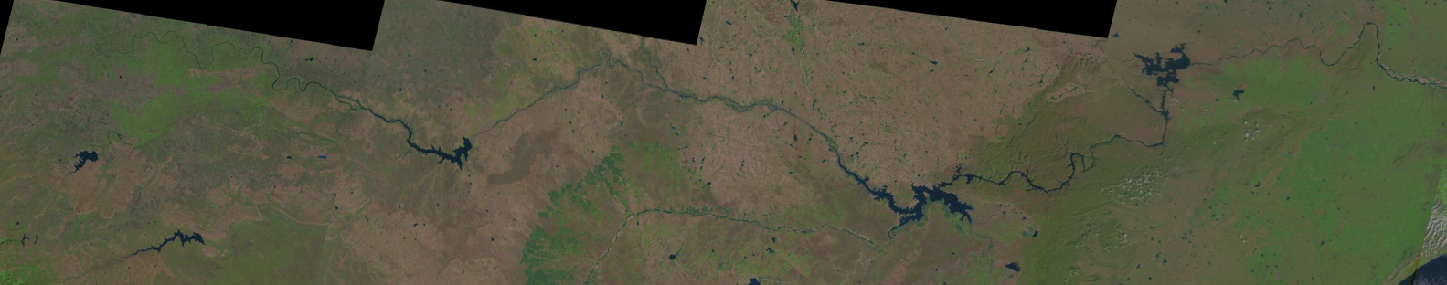

Figure 2: Process of Image Stitching

The approach was applied on Krishna River to monitor the changes over time. satellite images of the complete river were acquired from the USGS database. The images were collected at different times and seasons, enabling the monitoring of changes in the river's path over time. The imagery was combined using image stitching techniques to provide a smooth and comprehensive representation of the river. A panoramic view or a wider image can be made using the image stitching process, which involves aligning numerous photographs of the same scene. The programme was used to load the satellite photos, and preprocessing methods including color balance and image enhancement were used to make sure the images were of good quality and uniform across all of the images.

Algorithm for image stitching and Pre-processing :

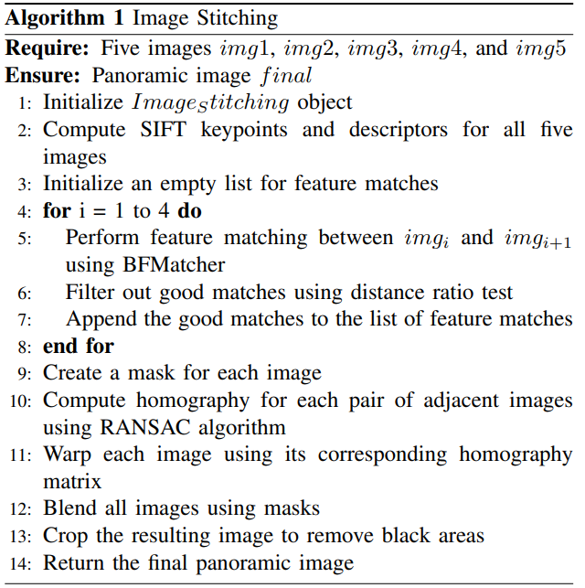

The goal of segmentation is to divide a picture into meaningful chunks from which pertinent information may be extracted. Image segmentation can be used to distinguish the river route from the surrounding surroundings in the context of river path change detection.

It provides several image segmentation algorithms, including thresholding, edge detection, and clustering. Thresholding is a frequent technique in image segmentation. It entails defining a threshold value and identifying all pixels in the image as foreground or background based on their intensity levels.

To calculate the length, area, and perimeter of the river path, contour detection algorithm. Contour detection follows identifying and extracting the boundaries of objects in an image. Once the contour of the river path is detected, you can use the contour properties such as length, area, and perimeter to calculate the required measurements.

Algorithm for calculate the Length, Area Perimeter and Centroid:

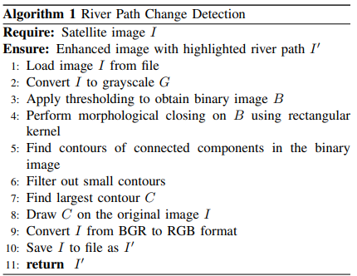

# results

Satellite images often contain multiple spectral bands that capture different types of information. In the case of the dataset used for river path change detection, the images acquired from the USGS database contain two layers: layer 4 and layer 5. Using the formula (B5 - B4) / (B5 + B4), where B4 and B5 stand for Band 4 and Band 5, the Normalised Difference Vegetation Index (NDVI) is derived to blend these two layers. While Band 5's wavelength range is 845-885 nm and its frequency range is 354.2-337.1 THz, Band 4's wavelength range is 655-670 nm and its frequency range is 449.4-434.9 THz. The NDVI is frequently employed in satellite pictures to identify water since it is sensitive to the presence of water and reduces the impact of other characteristics, such vegetation. NDVI = (NIR - Blue) / (NIR + Blue), where NDVI (Landsat 8) = (B5 - B4) / (B5 + B4), is the formula for removing the blue portion of the image. By calculating the NDVI for the two layers, a new image can be created that highlights areas of water and changes in water over time, which is useful for applications such as river path change detection.

Figure 4: Extracted Blue River.

Here, we're going to use QGIS to extract the blue area from an image. Combining image processing methods like thresholding and color-based segmentation can be used to accomplish this. By selecting the appropriate threshold values and applying segmentation algorithms to the image, we can isolate the blue region of interest.

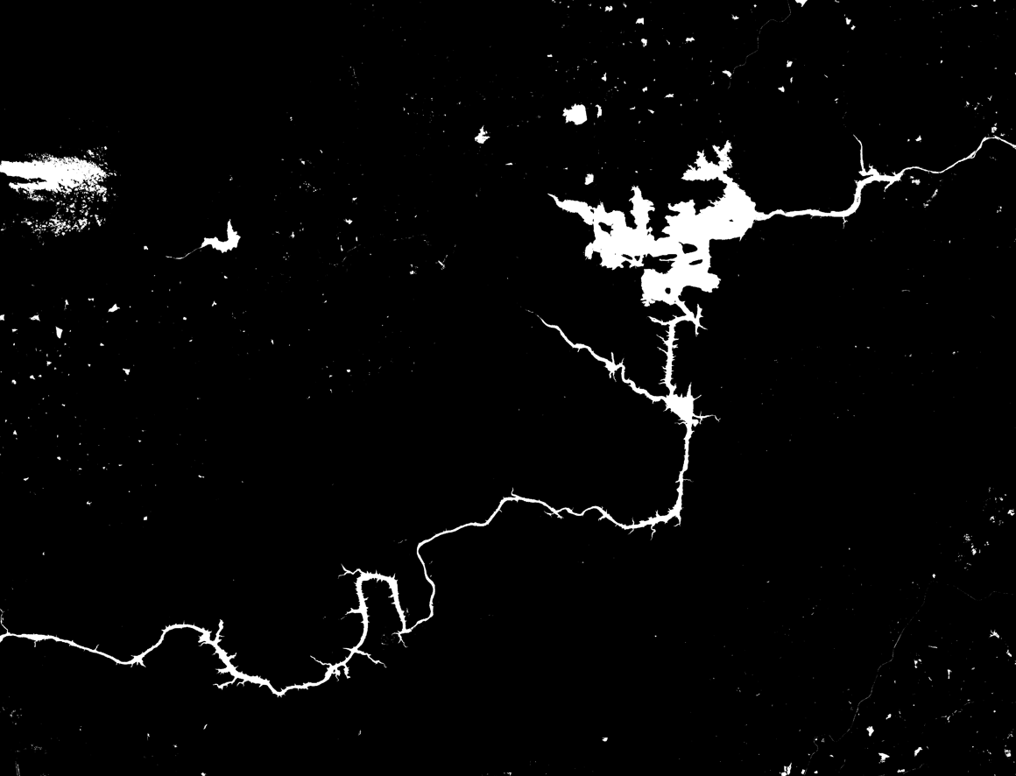

Figure 5: performing Thresholding.

Detected contour

Figure 6: River Detection using Contours.

the find Contours function is used to identify contour in the images. It takes arguments - the image on which to detect the contours.

In this case, the contour retrieval mode is set to RETR_EXTERNAL, which retrieves only the external contours (i.e., the boundaries of river in the image). Once the largest contour is identified, it is drawn onto the original image using the draw Contours function. The arcLength function, which requires the largest contour and a Boolean flag indicating whether the contour is closed or open, calculates the arc length (or perimeter) of the largest contour. Using the contourArea function, which accepts the greatest contour as an argument, the contour area is determined.

Figure 7: Output Image

The resulting image with the contour displayed with a title that includes the length, Perimeter, area and centroid of the red region.

Figure 5: Analysis of River Path Area

Figure 6: Analysis of River Path Length

|  |  |  |  |  |
| --- | --- | --- | --- | --- |
| Year | Area | Length | Perimeter | Centroid |
| 1994 | 930481.50 | 78774.24 | 78769.24 | (7278, 2158) |
| 1997 | 907600.50 | 76381.44 | 76348.44 | (5505, 2725) |
| 2003 | 841705.00 | 71573.67 | 71549.67 | (6692, 2373) |
| 2008 | 861705.00 | 72673.67 | 73549.67 | (5226, 2057) |
| 2011 | 907600.50 | 76381.44 | 76348.44 | (5505, 2725) |
| 2015 | 610230.50 | 61215.03 | 61208.03 | (5517, 2148) |
| 2018 | 898120.50 | 79158.17 | 79153.17 | (7293, 2148) |
| 2021 | 834570.00 | 73756.91 | 73755.91 | (6618, 2351) |
| 2023 | 841705.00 | 71573.67 | 71549.67 | (6692, 2373) |

Figure 7: Feature Parameter Table

The graph above depicts the variations in the area, length, perimeter, and centroid of the Krishna River from 1994 to 2023. As can be seen, there have been swings in the river's measurements over time. The river's area has declined from 930,481.50 in 1994 to 610,230.50 in 2015, but it has increased significantly to 834,570.00 in 2021. Similarly, the length and circumference of the river have shifted slightly over time.

Because the Krishna River is primarily used for agricultural purposes, these changes in the river's path can have a significant impact on irrigation. The river supplies water to a large amount of land, and any alteration in its course can cause problems with the irrigation system. For Finally, Table shows calculated values for each year, showing the changes in the area, perimeter, length and centroid over the past 30 years.

# Conclusion

To perform the river path change detection analysis on the Krishna River, satellite images can be obtained from various sources, such as Landsat or Sentinel. USGS Earth Explorer is a useful tool that can be used to download and analyze these satellite images. Once the satellite images are obtained, the river path change detection approach can be applied to detect and analyze changes in the Krishna River path over a period of 30 years, from 1994 to 2023. The analysis can involve comparing the properties of the largest contour representing the river in each image, such as area, perimeter, length, and centroid, to identify changes in the river path.

This analysis can provide valuable insights into the changes in the Krishna River path over time, which can be used for various purposes, such as monitoring the impact of human activities, planning for river restoration projects, and predicting the likelihood of floods or other natural disasters.

# references

[1] Lina Zhu, Jianqing Zhang, and Li Pa, “River Change Detection System Using Google Earth Satellite Imagery ”, Proceedings of the First International Multi-Symposiums on Computer and Computational Sciences (IMSCCS'06), IEEE, 2006.

[2] Puttinaovarat, Supattra & Saeliw, Aekarat & Pruitikanee, Siwipa & Kongcharoen, Jinda & Chai-Arayalert, Supaporn & Khaimook, Kanit & Horkaew, Paramate. (2021). River classification and change detection from landsat images by using a river classification toolbox. IAES International Journal of Artificial Intelligence (IJ-AI). 10. 948-959. 10.11591/ijai.v10.i4.pp948-959.

[3] Awatif Aziz, Yusuf Essam, Ali Najah Ahmed, Yuk Feng Huang, Ahmed El-Shafie,

An assessment of sedimentation in Terengganu River, Malaysia using satellite imagery,

Ain Shams Engineering Journal,

[4] HUANG, Hao-Hsiung & Lin, Shih-Yuan. (2001). Change Detection of River Way Using Aerial Images.

[5] Das, J.D., Dutta, T. & Saraf, A.K. Remote sensing and GIS application in change detection of the Barak River channel, N.E. India. J Indian Soc Remote Sens 35, 301–312 (2007).

[6] Soille, P., Grazzini, J. (2007). Extraction of River Networks from Satellite Images by Combining Mathematical Morphology and Hydrology. In: Kropatsch, W.G., Kampel, M., Hanbury, A. (eds) Computer Analysis of Images and Patterns. CAIP 2007.

[7] Md Altaf Hossain, Thian Yew Gan, Abul Basar M. Baki,

Assessing morphological changes of the Ganges River using satellite images, Quaternary International Volume 304,2013, Pages 142-155,ISSN 1040-6182,

[8] Robert K Kaufmann, Karen C Seto, Change detection, accuracy, and bias in a sequential analysis of Landsat

imagery in the Pearl River Delta, China: econometric techniques, Agriculture, Ecosystems & Environment,

Volume 85, Issues 1–3,2001,Pages 95-105, ISSN 0167-8809,

[9] Kummu, Matti & Lu, Xi Xi & Rasphone, Akchousanh & Sarkkula, Juha & Koponen, Jorma. (2008). Riverbank changes along the Mekong River: Remote sensing detection in the Vientiane-Nong Khai area. Quaternary International. 186. 100-112. 10.1016/j.quaint.2007.10.015.

[10] Wei, Zhihao & Jia, Kebin & Liu, Pengyu & Jia, Xiaowei & Xie, Yiqun & Jiang, Zhe. (2021). Large-Scale River Mapping Using Contrastive Learning and Multi

Source Satellite Imagery. Remote Sensing. 13. 2893. 10.3390/rs13152893.

[11] Islam, Md & Munir, Md & Bashar, Md Abul & Sumon, Kizar & Kamruzzaman, Mohammad & Mahmud, Yahia. (2021). Climate Change and Anthropogenic Interferences for the Morphological Changes of the Padma River in Bangladesh. American Journal of Climate Change. 10. 167-184. 10.4236/ajcc.2021.102008.

[12] Scherer, S., Rehder, J., Achar, S. et al. River mapping from a flying robot: state estimation, river detection, and obstacle mapping. Auton Robot 33, 189–214 (2012).

[13] Thakur, P.K., Laha, C. & Aggarwal, S.P. River bank erosion hazard study of river Ganga, upstream of Farakka barrage using remote sensing and GIS. Nat Hazards 61, 967–987 (2012).

[14] Haque, Md & Shishir, Sharmin & Mazumder, Anannya & Iqbal, Mehedi. (2022). Change detection of Jamuna River and its impact on the local settlements. Physical Geography. 1-21. 10.1080/02723646.2022.2026075.

[15] Aher, Sainath & Bairagi, Shashikant & Deshmukh, Pragati & Gaikwad, Ravindra. (2014). River Change Detection and Bank Erosion Identification using Topographical and Remote Sensing Data. international. 2.

[16] Maurya, Satya & Yadav, Akhilesh. (2016). Evaluation of course change detection of Ramganga river using remote sensing and GIS, India. Weather and Climate Extremes. 13. 10.1016/j.wace.2016.08.001.

[17] FAP 24. River survey project: An Observation of the Changing Trends of a River Channel Pattern in Bangladesh Using Satellite Images Dhaka, Bangladesh, 1996

[18] Boavida, I.; Santos, J.M.; Cortes, R.V.; Pinheiro, A.N.; Ferreira, M.T. Assessment of instream structures for habitat improvement for two critically endangered fish species. Aquat. Ecol. 2011, 45, 113–124.

[19] Nguyen Khoi, Dao & Dang, Thanh & Pham, Lien & Loi, Pham & Thuy, Nguyen Thi & ky phung, Nguyen & Bay, Nguyen. (2020). Morphological change assessment from intertidal to river-dominated zones using multiple-satellite imagery: A case study of the Vietnamese Mekong Delta. Regional Studies in Marine Science. 34. 101087. 10.1016/j.rsma.2020.101087.

[20] M. Luqman, U. U. H. Shah, S. Khan and F. Akmal, "River channel dynamics detection using Remote Sensing and GIS technologies: A case study of River Chenab in Indo-Pak Region," 2017 Fifth International Conference on Aerospace Science & Engineering (ICASE), Islamabad, Pakistan, 2017, pp. 1-5, doi: 10.1109/ICASE.2017.8374275.

[21] Mahar, Gohar & Zaigham, Nayyer. (2014). Examining Spatio-Temporal Change Detection in the Indus River Delta with the Help of Satellite Data. Arabian Journal for Science and Engineering. 40. 1933-1946. 10.1007/s13369-014-1494-8.

[22] Moghaddam, M.H.R., Sedighi, A. & Fayyazi, M.A. Applying MNDWI index and linear directional mean analysis for morphological changes in the Zarriné-Rūd River. Arab J Geosci 8, 8419–8428 (2015).

[23] Potter, C. Vegetation cover change in the Upper Kings River basin of the Sierra Nevada detected using Landsat satellite image analysis. Climatic Change 131, 635–647 (2015). https://doi.org/10.1007/s10584-015-1397-z

[24] Morgan, Bryn & Chipman, Jonathan & Bolger, Douglas & Dietrich, James. (2020). Spatiotemporal Analysis of Vegetation Cover Change in a Large Ephemeral River: Multi-Sensor Fusion of Unmanned Aerial Vehicle (UAV) and Landsat Imagery. Remote Sensing. 13. 51. 10.3390/rs13010051.

[25] R. Titlee, M. S. Islam and N. Ahmed, "Analysis of the Morphological Changes of the River Padma Along Naria Upazila through Supervised Classification of Satellite Images," 2020 2nd International Conference on Advanced Information and Communication Technology (ICAICT), Dhaka, Bangladesh, 2020, pp. 302-307, doi: 10.1109/ICAICT51780.2020.9333474.